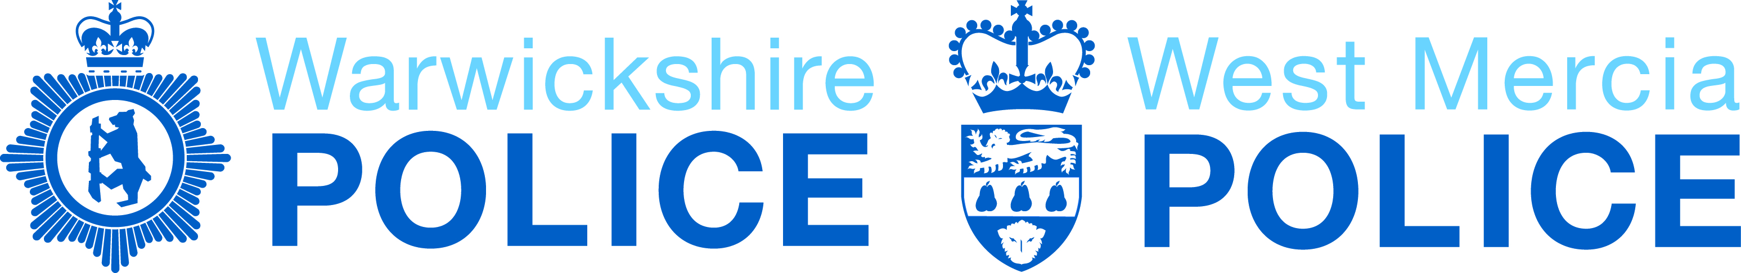

Internal Ethics Committee

Terms of Reference

V3 161212

Background

Police forces across England and Wales have implemented the Code of Ethics produced by the College of Policing. In Warwickshire Police and West Mercia Police this has been embedded by a range of methods to allow read across between the Code and our Vision and Values. Oversight of ethics has to date been provided by the OPCC’s Trust, Integrity and Ethics Committee (TIE) and HMIC Inspection (Legitimacy).

In an effort to further embed ethics within the forces it has been decided to create an Internal Ethics Committee, to support the ethical development of the forces and to supplement the work of the external TIE. The chair of the Internal Ethics Committee will provide the link to the TIE via regular updates.

Purpose

The purpose of the Internal Ethics Committee is to provide a sounding board for ethical issues faced in everyday policing situations; thereby allowing officers and staff to submit issues or dilemmas affecting their work and working environment, to allow a discussion and consideration before submitting a view back to the force.

Objectives

The objectives of the Internal Ethics Committee are to:-

- Enrich the ethical development of the forces, to further embed the Code of Ethics
- To ensure that the officers and staff working in the forces are able to understand that ethics are something we need to do for ourselves, not having them imposed upon us
- To support officers and staff as they seek to address issues in an ethical manner by providing a resolution of the issue submitted
- To allow consideration of issues beyond the operational, by seeking to understand implications of policing activity and the provision of functions which are vital to ensure operational policing can be delivered
- To provide a resolution to the issues raised in a practical manner
- To provide information to the forces as a whole on the issues discussed.
- To act as a conduit into the Trust, Integrity and Ethics Committee so that recommendations can be discussed and acted upon as appropriate.

Methodology

Officers and staff will be encouraged to submit issues to the committee which are challenging their experience and understanding. The committee will then discuss these topics, undertaking appropriate research if necessary, to then allow the preparation of a short précis of the discussion and an agreed resolution position.

Membership

The following should constitute the membership of the committee:-

- Chief Officer lead (Chair)
- Head of Professional Standards (Vice Chair)
- Head of Legal Services
- Representatives of the forces’ chaplaincy
- Volunteers from the force – 4 present per meeting
- Independent academic ethicists from local universities.
- HR Representative
- Head of Learning and Development
- TIE Committee Member

Frequency

The committee will meet quarterly in the first instance with the option of sub meetings to facilitate research and report back to the committee.

