AGENDA
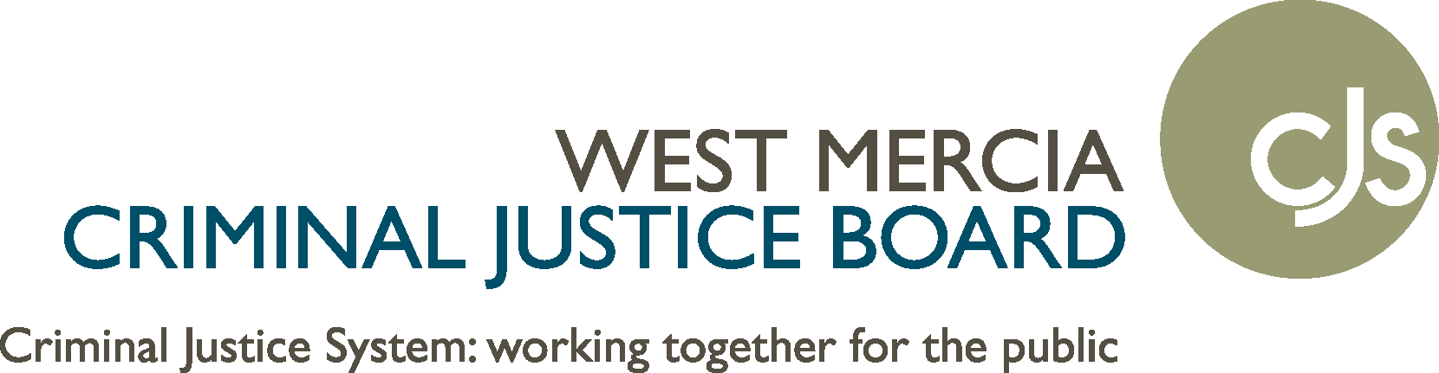
VICTIMS’ BOARD
MEETING: 11:15 – 13.00 THURSDAY 17 DEC 2020

ZOOM – You can use Zoom via your web-browser for free, or via the app
Meeting ID: 836 1752 1568
Password: 469994

https://us02web.zoom.us/j/83617521568?pwd=ODFldzJBNHFpYmpFdHhHNTNZNU9qdz09

Business Item Lead & Purpose

11.15
1. Welcomes / Introductions / Apologies | Chair
11.20 – 11.25
2. Minutes and Actions Arising from Sept 2020  11.25 – 11.40  3. PCC Victims Strategy – Draft  11.40 – 12.00  4. PCC Victim Services Dashboard  12.00 – 12.15  5 Victims’ Code of Practice + Assessment Tool  12.15 – 12.20  6. MoJ / NPCC Attrition Project  12.15 – 12.30  7. WMP Victim and Witness Update  12.30 – 12.40  8. Impact of Covid-19 on Victims and Witnesses  12.40 – 12.55  9. Agency Updates – Reports and by exception | Chair  CJ  CR  CJ  CJ  MC  CR  ALL
12:55 – Close of meeting

10. Any other business | Chair
Time / Date of next meeting | WEDNESDAY, 24 MAR 2021  11:15 – 13:00  Hindlip Park, WR3 8TA

