West Mercia Police and Crime Commissioner

Commissioner’s Community Fund

1 April 2025 – 31 March 2026



Grant Application Form

|  |  |
| --- | --- |
| Organisation Name: |  |
| Project Name: |  |
| Amount of funding applied for: |  |

Please read the Application Guidance and the Policy and Procedures note before completing this from.

Completed forms should be emailed to [grants@westmercia.police.uk](mailto:grants@westmercia.police.uk).

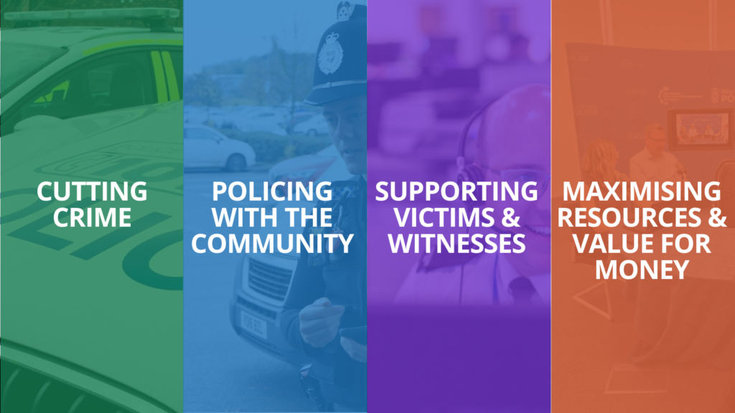

**Before completing this application, please refer to the Commissioner’s Community Fund Application Guidance. This will assist you in understanding all the requirements of this form.**

Section 1: Organisation Details

* 1. Main contact details

|  |  |
| --- | --- |
| Name of key contact: |  |
| Job title of key contact: |  |
| Local policing area: |  |
| Name of Superintendent: |  |
| Is this project specific to your LPA? *(You will need consent from relevant Superintendents)* |  |
| Organisation address: |  |
| Telephone number: |  |
| Email: |  |
| Date of application: |  |

Please detail any communication needs your main contact has e.g. textphone, sign language, braille.

|  |
| --- |
|  |

1.2 Due Diligence Checklist

|  |  |  |  |  |
| --- | --- | --- | --- | --- |
|  | Yes | No | N/A |  |
| Does your organisation have current public liability insurance? |  |  |  | Value: £ |
| Does your organisation have current employer’s liability insurance? |  |  |  | Value: £ |
| Does your organisation have an active Management Committee or Board of Trustees with at least three people who are unrelated? |  |  |  |  |
| Does your organisation have signed annual accounts? If the organisation is under 12 months old, do you have a 6-month cash flow showing predicted income and expenditure? |  |  |  |  |
| Does your organisation have a bank account with two unrelated signatories? |  |  |  |  |
| Does your organisation have a current safeguarding children and/or vulnerable adults’ policy? |  |  |  | If your project intends to work with children or vulnerable adults, you will need to attach a copy of these policies. |
| In relation to safeguarding, where the proposed project involves delivery of regulated activity can you confirm that all staff are subject to valid enhanced DBS checks? |  |  |  |  |
| Does your organisation have the following current policies?   * Data protection / information security policy? * Equality and diversity policy? * Health and safety policy? |  |  |  |  |
| Is your organisation registered with the ICO? |  |  |  | Reg number: |

Section 2: Your Funding Proposal

2.1 Project Details

|  |  |
| --- | --- |
| Project name: |  |
| Names of all individuals involved in delivery of the project: |  |
| Project description: |  |
| Project purpose: |  |
| Project timescale: *length of time to complete, project start and end date* |  |

2.2 Project Evidenced Need, Aim and Objectives

|  |  |  |
| --- | --- | --- |
| How do you know there is a need for this project? Do you have examples of this type of intervention working elsewhere? |  | |
| How specifically will your proposed project address the issues you have identified above and how is it additional to any existing provision in West Mercia? |  | |
| Please list how the applicant will measure the initiative. *i.e. number of people attending, number of times used, number of people engaged with.* |  | |
| Please list the outcomes that the project seeks to achieve and how they will be measured. | Outcome: | Measurement: |
| *e.g. reduction in volume of ASB incidents* | *e.g. number of ASB incidents pre and post intervention* |
|  |  |
|  |  |
|  |  |  |
| How will you demonstrate whether your project has been a success? |  |  |

2.3 Priority Activities

Funded projects must contribute to meeting the PCC’s priorities as set out within the Safer Communities Plan. Please tick the main objective(s) your project will contribute towards – **Please tick all that apply, being mindful that all should be SMART (specific, measurable, achievable, relevant and time-bound)**

|  |  |
| --- | --- |
| Cutting Crime |  |
| Reduce crime and reoffending and tackle the drivers of crime and ASB. |  |
| Increase the number of offenders brought to justice, with improved criminal justice outputs and outcomes. |  |
| Improve feelings of safety amongst communities. |  |
| Improve public confidence and satisfaction. |  |
| Significantly reduce the number of people killed or seriously injured on our roads. |  |
| Policing with the Community |  |
| Improve confidence and satisfaction within the community. |  |
| Increase visibility and accessibility across all areas of policing. |  |
| Improve communication and engagement channels, resulting in communities hearing from their police service, and police hearing from communities. |  |
| Communities receive the right service from the police which is proportionate and reasonable. |  |
| Supporting Victims and Witnesses |  |
| Victims and survivors feel their voice is heard in the criminal justice system. |  |
| Improve the criminal justice experience and outcomes. |  |
| Increase confidence and trust in the criminal justice system. |  |
| Improve police response to victims. |  |
| Victims and survivors receive high quality care to support them to cope and recover, as much as possible, from the harm they have suffered. |  |
| Maximising Resources and Value for Money |  |
| Ensure effective medium term financial planning is in place which sets the annual allocation of policing resources within the budget available. |  |
| A police force which delivers efficient and effective services to the public. |  |
| An understanding of how the organisation uses its resources and an increase in the economic potential of them. |  |
| A policing service model which is sustainable, utilising local business and public partners who can be best placed to deliver services that meet the needs of the public. |  |

2.4 Project Scope

Is this grant for new work , or to support/extend your organisation’s existing work ? If it is to support existing work, tell us how this work was previously funded, why this funding is no longer available, and what your project/service has achieved so far.

|  |
| --- |
|  |

2.5 Project Sustainability

The PCC cannot provide on-going funding for projects. Please tell us how your project will continue, if applicable, once the Commissioner’s funding has finished.

|  |
| --- |
|  |

2.6 Information Sharing Agreement

Does your project require the sharing of information from or with other agencies?

Yes  No  N/A

If yes, do you have GDPR compliant information sharing agreements (ISA) in place?

Yes  No  N/A

Please provide brief details – who is the information sharing agreement between. When was it written and signed etc

|  |
| --- |
|  |

2.7 Project Delivery and Management

Please tell us who will manage the project and how you will ensure the project is delivered effectively and well managed.

|  |
| --- |
|  |

Section 3: Financial Information

|  |  |
| --- | --- |
| Total project cost: | £ |
| Match funding: *(other funding which has been sourced for this project)* | £ |
| Total amount of funding being sought: | £ |
| Please list the specifics that the funding will be spent on if awarded: |  |
| Please detail when the fund will be spent/product purchased, e.g. by the end of March or before if applicable: *Please note that all funding must be spent and projects completed by 31st March and any underspends will have to be returned to the OPCC* |  |

Please acknowledge that the PCC and / or logo should be considered in all merchandising and promotion, and that photos should be sent to our communications team opcccomms@westmercia.police.uk if relevant.

Section 4: Equalities Monitoring

If relevant, how does the project support, monitor and capture equalities data to demonstrate equality of opportunity for project beneficiaries? How will your project support those with protected characteristics, by and for groups, under-represented, marginalised cohorts, groups or communities?

|  |
| --- |
|  |

Section 5: Conflict of Interest and Final Declaration

5.1 Convictions

I/We hereby confirm that my/our organisation or any directors or partners or any other person who has powers of representation, decision or control have not been convicted, or under investigation for any of the following offences:

* Conspiracy.
* Corruption.
* Bribery.
* Fraud or theft.
* Any offence listed:

1. In section 41 of the Counter Terrorism Act 2006; or
2. In Schedule 2 of that Act where the court has determined that there is a terrorist connection.

* Any offence under sections 44 to 46 of the Serious Crime Act 2007 which related to an offence covered by subparagraph (f).
* Money laundering or offences relating to the proceeds of criminal conduct; or
* An offence under section 4 of Asylum and Immigration (Treatment of Claimants etc) Act 2004.
* Any other offence under Section 59A of the Sexual Offences Act 2003.
* An offence in connection with the proceeds of drug trafficking.
* Any other offence within the meaning of Article 57(1) of the Public Contracts Directive.

5.2 Reputation

I/We hereby confirm that within the past three years my / our organisation and its directors / trustees have not:

* Violated applicable environmental, social, and labour obligations established by EU law, national law, collective agreements or by the international environmental, social and labour law provisions.
* Been made bankrupt or been the subject of insolvency or winding up proceedings.
* Been guilty of grave professional misconduct.
* Tried to unduly influence the decision-making process of the Office of the Police and Crime Commissioner.
* Tried to obtain confidential information that may confer undue advantage; or
* Provide misleading information that may have a material influence on decisions concerning grant award.

For the purposes of this declaration, a Relevant Conviction is a conviction involving dishonesty, violence or sexual assault and a Regulated Activity has the meaning given in Schedule 4 to the Safeguarding Vulnerable Groups Act 2006.

I/We hereby confirm that no individual, employed or associated with the Beneficiary, has:

* Disclosed that they have a Relevant Conviction.
* Been found by the Beneficiary to have any Relevant Convictions (whether because of a police check or through the DBS procedures or otherwise); or
* Been barred from, or whose previous conduct or records indicate that they would not be suitable to carry out Regulated Activity or who may otherwise present a risk to service users, and no such individual is or shall be employed or engaged in any part of the provision of the Funded Services.

I consent to West Mercia OPCC conducting Creditsafe checks on named applicants and organisations.

5.3 Conflict of Interest

Conflict of Interest refers to situations in which personal interest (which may include financial interests) may compromise, or have the appearance of, or potential for, compromising professional judgement and integrity and, in doing so, the best interests of the Police and Crime Commissioner.

Examples of conflicts of interest include: *(this is not an exhaustive list)*

* Being employed by (as staff member or volunteer) any Police Force or Office of the Police and Crime Commissioner (OPCC).
* Being a member of a Police Force or OPCC management/executive board.
* Canvassing, or negotiating with, any person with a view to entering any of the arrangement outlined above.
* Having a close member of your family (which term includes unmarried partners) or personal friends who falls into any of the categories outlined above.
* Having any other close relationship (current or historical) with any Police Force or OPCC.
* Failure to comply with OPCC’s Gifts, Gratuities and Hospitality Procedure.

I/We hereby

Confirm that no conflicts of interests exist between the grant applicant organisation (including any employee, volunteer, or board member) and the Commissioner (or any of his officers, members or advisors).

Or

Declare that the grant applicant / someone associated with the grant applicant does have a conflict of interest that may prevent out full and unprejudiced participation in this procurement process. The nature of this conflict of interests is described below:

|  |
| --- |
|  |

5.4 Data Protection

All information submitted on this application will be held by the Office of the Police and Crime Commissioner (OPCC) and will contribute directly to the decision that is made regarding allocations of funding and for our own research purposes.

We will provide copies of all or some of this information to individuals and organisations we consult with when assessing applications, monitoring grants, and evaluating funding processes and associated impacts. These organisations may include external auditors and other organisations involved in delivering the projects.

Summary information from this application may be published on our website to assist other applicants in the future and to inform members of the public of the projects funded by the PCC.

Full grant applications will be retained for a maximum of 6 years (plus current year). Information will be retained on a database at the OPCC for statistical and monitoring purposes.

5.5 Freedom of Information

The Freedom of Information Act 2000 gives members of the public the right to request any information that we hold. This includes information received from third parties such as grant applications and grant holders.

If information is requested under the Freedom of Information Act, we will release it, subject to exemptions; although we may choose to consult with you first. Your signature on this form confirms that you understand the PCCs obligations under the Data Protection Act 1998 and the Freedom of Information Act 2000.

5.6 Declaration

|  |  |
| --- | --- |
| I confirm that, where applicable, I have carried out all relevant due diligence on the organisation or individuals involved in the delivery of this project and that the activity is suitable and not likely to adversely impact on the reputation of OPCC or the Force. | Name …………………………………………  Signature ……………………………………….  Date ………………………………………. |

I hereby certify that all the information provided by me in this application is correct, accurate, and complete to the best of my knowledge and that I have read the Application Guidance and the Terms and Conditions.



Signed …………………………………………………… Applicant

Signed …………………………………………………… Superintendent

If your project is not specific to your LPA, you are required to get support from the other relevant Superintendents.

Signed ……………………………………………………

Signed ……………………………………………………

Signed ……………………………………………………

Signed ……………………………………………………